|  |  |  |
| --- | --- | --- |
|  | **ASEAN Entrepreneurship Journal (AEJ)** |  |

Paper Title

**Full Name of Author 1Author origin 1, *Full Name of Author 2Author Origin 2**

1 Department, University, University Address, author’s email address (name@univerity.edu)

2 Department, University, University Address, author’s email address (name@univerity.edu)

*Corresponding Author

|  |  |  |  |
| --- | --- | --- | --- |
| Abstract: | ARTICLE INFORMATION | | |
| AEJ format requires you to include an abstract at the start of your paper, followed by a list of keywords. In the “Styles” section in Microsoft Word, you can find the appropriate styles for all the different sections and headings in the paper, which are already applied here. For example, the “AEJ Abstract Body” style is applied to this text, the “AEJ Abstract Keywords” style to the next section. Note that the titles “Abstract” and “Keyword” should remain as they are written here: italicized, bold and followed by a colon. To the right of the abstract are article submission information with the appropriate style applied. The corresponding style within the style sheet is also available. | Received:  Revised  Accepted:  Published: | xx  xx  xx  xx | xx  xx  xx  xx |
| Keywords: Entrepreneurship Education, Application-Oriented Universities, Strategic Recommendations, Implementation |  | | |

This is the level 1 heading - INTRODUCTION

The body text of your paper begins here. Use headings to divide your paper into sub-topics as needed, starting with Level 1 headings, followed by Level 2 headings for further subdivisions, and so on. Ensure each level has at least two headings, as a single heading at any level should be avoided. Level 1 headings are formatted in **BOLD AND ALL CAPS**, Level 2 headings are written in **Bold with Title Case Capitalization**, and Level 3 headings are written in *Italics with Title Case Capitalization*. If dividing your paper into sections is unnecessary, you may choose to omit headings altogether. In most cases, papers will make extensive use of Level 1 headings to structure the content effectively.

Use the enter key to start a new paragraph. The appropriate spacing and indent are automatically applied. The text under heading 1 is not indented and fully justified. In the style sheet, this text style is labeled AEJ Normal 1.

When transferring text from another document with a different format, it is recommended to use the Paste > Special > Text Only option. This helps avoid formatting issues in your document. After pasting, apply the appropriate style from the provided style sheet to ensure consistency or you may do so manually.

This is another level 1 heading - LITERATURE REVIEW

This is a Level 2 Heading

Text following a Level 2 heading should be aligned so that the text is indented to match the position of the heading’s first letter, measured at 1 centimeter from the left margin.

This is a Level 3 Heading

Like Level 2 Heading, Level 3 Heading will also have its text following the header indented at 1.5 centimeters.

This is another Level 3 Heading

Beyond Level 3, there are no specific headings. You may want to consider using a bulleted point or a numbered point:

* This is an example of a bulleted point.
* The styling of the bulleted point will be applied according to the default document template.
* **Title** - If a bulleted point requires further explanation, you may bold the title of the point and follow it with a dash before providing the additional details as shown here.
* Same styling would also throughout the document whenever bulleted point is applied.

This is another Level 3 Heading:

1. Alternatively you may want to use numbered point.
2. The styling of the bulleted point will be applied according to the default document template just as bulleted points.
3. Title – If a point requires further explanation, we may follow the method applied for bulleted points. The title is in italics followed by a dash before inserting details.

This is another Level 1 Heading - RESEARCH METHODOLOGY

Equations should be typed in either Times New Roman or Symbol font, or, if the equation is multileveled, insert into your text as a graphic instead. The equation is to be placed at the centre of the page as a separate paragraph from the text. An example of a single equation is as below using the equation editor in Microsoft Word:

$${\left(1+x\right)}^{n}=1+\frac{nx}{1!}+\frac{n\left(n-1\right)x^{2}}{2!}+…$$

Multi-leveled equations should be inserted as a graphic such as the following:

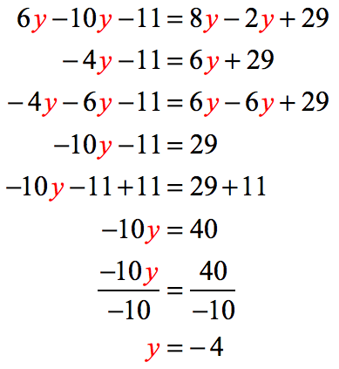

This is another Level 1 Heading – RESULTS AND DISCUSSION

This is Another Level 2 Heading - Tables

Position tables in the centre of the page, separated from the surrounding text in distinct paragraphs. The table label should be placed at the top, formatted in Times New Roman, 9pt, and centred. The recommended method for creating the label is to insert an extra row above the table with no visible borders, except for the top border of the displayed table. Table content should also use Times New Roman, 9pt, with bold formatting applied to the column headers. All the styles described above are preconfigured in the style sheet. An example of a table is provided below:

|  |  |  |
| --- | --- | --- |
| Table 1: Table Title Here | | |
| No | Dimension | Questions |
| 1 | Understanding and Necessity of EE | 1. Do you know about EE in the universities? 2. Do you think it is necessary for universities to carry out EE? |
| 2 | Evaluation on EE Implementation | 1. What entrepreneurship courses do you think are helpful for innovation and entrepreneurship? 2. How much do you know about entrepreneurial communities or institutions in your school? 3. What service functions do you think business incubation bases or mass entrepreneurship spaces should provide? 4. Which of the following types of EE activity and services have you received in your university? 5. What do you think are the effective EE activities in your university? 6. If you start your own business, how do you finance it? 7. Do you think the entrepreneurship department of your university provides enough services for students? |
| Source:XXXXXXXX | | |

You are welcome to customise the presentation of table content to suit your needs. While the default style sheet aligns tables to the center, writers may adjust the alignment or formatting based on their preferences. Flexibility is allowed, as we are not strict about how information is presented in tables.

If a table includes a cited source, place the source citation in the bottom-right corner of the table. Align the text to the right and format it in Times New Roman, 9pt.

Figures

Like tables, figures should be centered on the page, with their labels positioned directly below the figure. The recommended approach is to create a text box, place it at the desired location, and insert the figure into the text box. Include the figure label within the text box, centrally aligned, and format it in Times New Roman, 9pt. Apply text wrapping to the figure, ensuring a spacing of 0.3 cm above and below to maintain clear separation from the surrounding text. Additionally, tables should be anchored to a specific location on the page when text wrapping is applied.

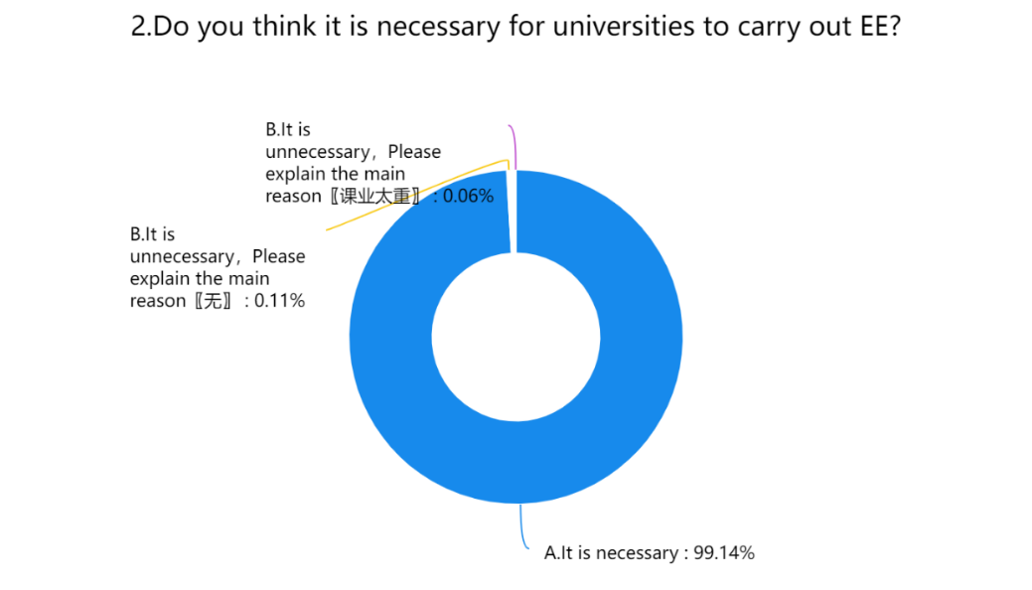

Figure 1: Necessity of Conducting EE

This is another Level 1 heading – CONCLUSION

This is Another Level 2 Heading – Tables

In this section, the author(s) should clearly highlight the study's implications, detailing its contributions to theory, practice, or policy. This should be followed by practical recommendations and suggestions for future research to extend the study's findings. Finally, the section should provide a concise and insightful conclusion, summarizing the key outcomes and their significance.

This is another Level 1 heading – AUTHOR CONTRIBUTION, FUNDING, ACKNOWLEDGEMENT AND CONFLICT OF INTEREST

AEJ requires authors to include statements on their contributions, funding, acknowledgments, and any conflicts of interest. Examples of these sections are provided in the following paragraphs.

**Author Contributions**: Ren Zhiyi: Writing-Original draft preparation, Conceptualisation, Project administration. Norazah Abdul Aziz: Methodology, Software, Validation. Hardy Loh Rahim: Writing-Original draft preparation, Supervision.

**Funding**: This research received no external funding.

**Acknowledgements**: I would like to extend my deepest gratitude to Yu Yongmiao from Langfang Normal University and Liu Qian from Hengshui University for their invaluable assistance in organising the survey. Their support was crucial in gathering the extensive data required for this study, and this work would not have been possible without their help.

**Conflicts of Interest:** The authors declared no conflicts of interest regarding this work.

AEJ follows APA 7th edition guidelines for citing references in the paper. Examples of references are provided below. The style sheet includes formatting for reference indentation; however, italicizing the titles of papers must be done manually.

References

Bacigalupo, M., Kampylis, P., Punie, Y., & Van den Brande, G. (2016). EntreComp: The Entrepreneurship Competence Framework. In *Luxembourg: Publication Office of the European Union*. https://doi.org/10.2791/593884

Bai, L., & Qin, W. (2019). Construction of Innovation and Entrepreneurship Education System in Higher Physical Education Institutes. *2019 7th International Education, Economics, Social Science, Arts, Sports and Management Engineering Conference*, *Ieesasm*, 2456–2459. https://doi.org/10.2991/icem-18.2019.135

Boldureanu, G., Alina, M., Bercu, A., Boldureanu, D., & Bedrule-grigorut, M. V. (2020). Entrepreneurship Education through SucessfulEntrepreneurial Models in Higher Education Institutions. *Sustainability*, 1–33.